Department of Statistics

The Wharton School

University of Pennsylvania

STAT 603 August 2004

Module 9

Confidence Intervals

A 95% Confidence Interval for μ
A convenient way to convey the precision of a statistical estimate is to report a range of “probable” values of the parameter. This is done by reporting a confidence interval.

When x₁,…, x_{n} is an iid sample from a population

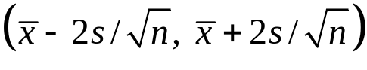
is called an (approximate) 95% confidence interval (CI) for the population mean μ

The “95%” part of this is known as the confidence level of the interval.
Example
For the stock prices of General Motors (GM92), 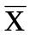 = .0016 and s = .0202 and n = 507

The resulting (approximate) 95% CI for μ is

= (-.0002, .0034)

Key property: 95% CIs contain the population mean μ “about 95% of the time.”

To see why, recall from Module 8 that

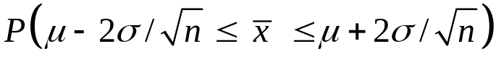 ≈ 95%
so if we estimate σ by s, then

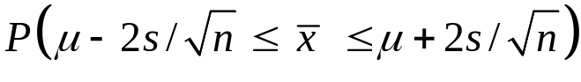 ≈ 95%

Thus, is within 2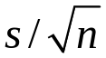 of μ for about 95 % of samples.
Exact Confidence Intervals For μ

When x₁,…, x_{n} iid ~ N(μ,σ²), exact confidence intervals for μ take the form

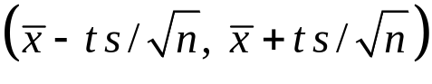

where t is a predetermined constant that depends on the sample size n and the desired confidence level (again, this is usually 95%).

For example, if n = 20,

t = 2.09 yields a 95% CI and t = 1.72 yields a 90% CI.

Good news: JMP provides exact 95% CI limits for μ

Example: The 95% CI for μ for the GM92 returns

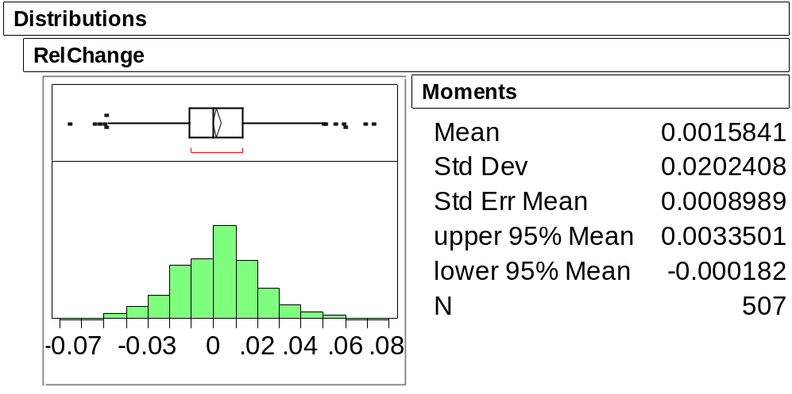
The 95% CI for μ here uses the exact procedure. How does it compare with the approximate interval (-.0002, .0034) on page 9-2?

The "±2 standard error" Rule of Thumb

Unless n is small (≤ 30) and precise confidence is needed, the approximate
95% CI bounds given by 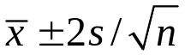 are fine.
Prediction Intervals are Not Confidence Intervals!

CAREFUL! When x₁,…, x_{n} are iid ~ N(μ,σ²), the (approximate) 95% prediction interval (PI) for a future draw from this population is computed as

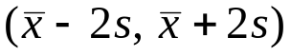

This is not the same as the (approximate) 95% CI for the population mean μ

It is wider because individual values are more variable than averages.

Example: Let’s again revisit the 400 observations of motor shaft diameters in ShaftXtr.jmp. (BBS, p.97)

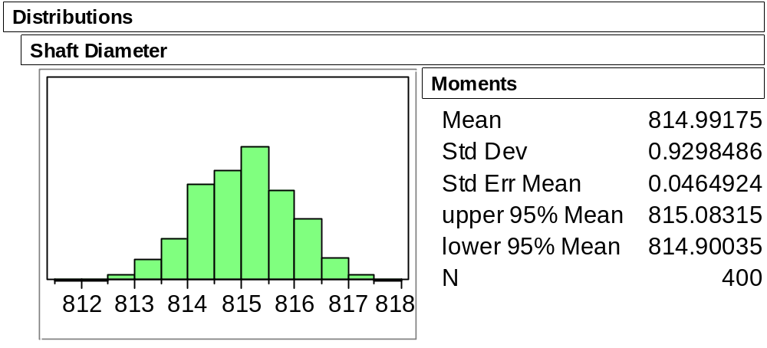

A 95% CI for the mean of the shaft-making process is (814.90, 815.08).

Assuming the process remains in control (recall control charts, as shown on BBS p.75), an approximate 95% prediction interval for the diameter of a future shaft is

(814.99 – 2(.93), 814.99 + 2(.93)) = (813.13, 816.85).

Which interval is wider? Why?

Suppose that instead of one overall confidence interval, we wanted separate 95% CIs for each day. JMP easily provides these as (BBS, p.101)

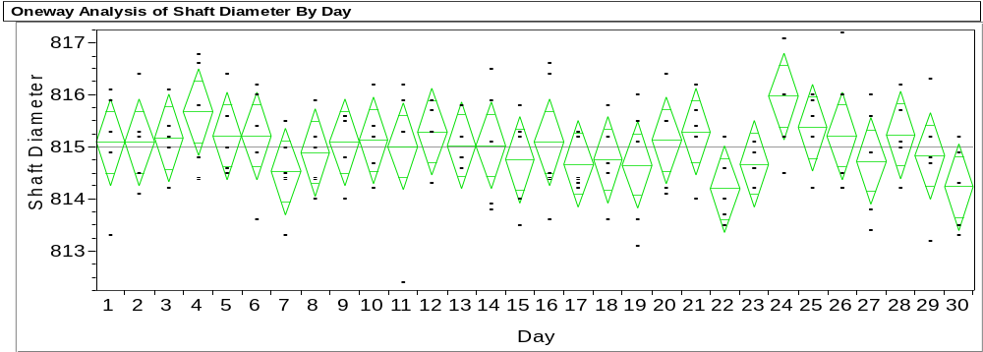
The center of each diamond is the daily sample mean and the tips of each diamond are the 95% confidence limits for the true daily mean.

Note that 95% CI for day 24 does not cover the overall mean. Is this worrisome?
Choosing a Needed Sample Size n

The width of the 95% CI for the mean of the motor shaft process is (using all of the data) 815.1–814.9 = 0.2 (page 9-6)

What would happen to the width of the 95% CI for the mean if the sample size n was larger?

Using the ±2 standard error rule of thumb, the width of a 95% CI for the mean is
Width = 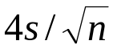

Suppose we doubled the sample size from n to 2n. What would happen to the width of the interval?

Suppose it was of interest to obtain a 95% CI width less than a particular width, say MaxWidth. If a preliminary estimate for s, call it s_{GUESS} , was available, how large should n be chosen to obtain Width ≤ MaxWidth?
An Intent to Purchase Survey (BBS, p.104)

A manufacturer of consumer electronics would like to know how many households intend to purchase a computer next year. The file CompPur.jmp contains the yes or no responses of 100 households.

The JMP summary for the categorical yes-no variable Intend_to_Purchase

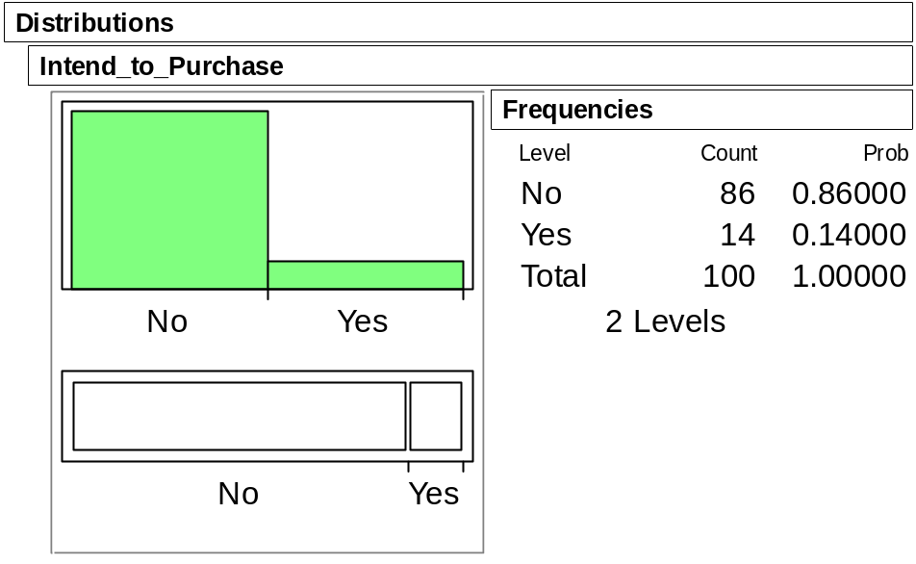
Management hopes that the proportion is at least 25% in order to justify sales projections.
Does the survey dash their hopes?

Assuming the survey has truly sampled the population of interest, the issue here is:

Can the difference between 14% and 25% reasonably be attributed to chance
(i.e. to sampling variation)?

To answer this question with a confidence interval, we transform the variable Intend_to_Purchase to a numerical variable Intend:

Intend = 0 if Intend_to_Purchase = No
Intend = 1 if Intend_to_Purchase = Yes

Because Intend is numerical, the JMP summary provides moments and the 95% CI for the (unknown) population proportion

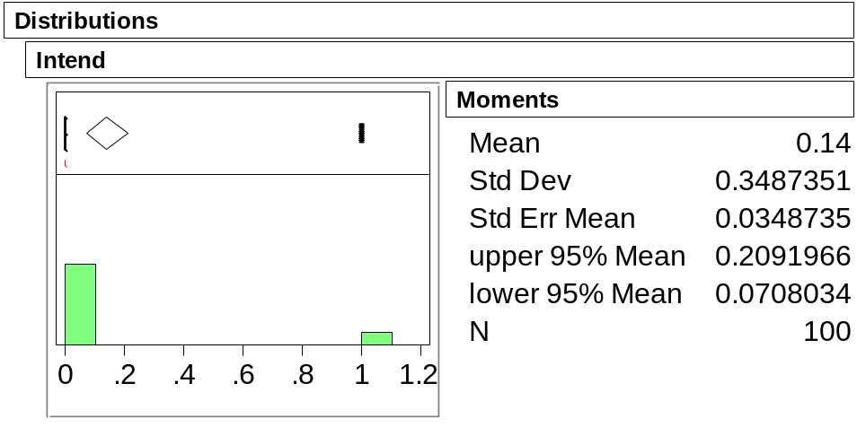

Note that the sample proportion 14% is the mean of Intend.

Now do management’s hopes seem reasonable?
Take-Away Review

A confidence interval is a range of plausible values for the population parameter. The confidence level of the interval indicates just how plausible this range is.

Most of the confidence intervals that we’ll use are 95% confidence intervals.

To form a 95% confidence interval for the population mean, we can use the exact JMP interval or the approximate interval
This form is typical of most of the CIs we will use in this course and Stat 621, namely

(estimated value ± 2 SE(estimated value))
Next Module
If a value lies outside of the confidence interval, our analysis today suggests that “it’s not plausible” at some level of confidence. But once a value lies out of the interval, that’s about all we can say.

Statistical tests take this idea further and directly measure the reasonableness of a hypothesized population value.

Using Analyze > Distribution, it is listed in the Moments output..
Use the Fit Y by X command, right click on the title bar, selecting Display Options and then Mean Diamonds. You can only get this display if the X variable in the plot is ordinal or nominal.
We only consider 30 days here so that the plot fits on the page.
Using Analyze > Distribution, the output for a categorical variable takes this form.

